From my understanding and learning of load balancers and there job I have constructed a diagram to what I believe is a balanced and scalable design or set-up.

The set-up includes a firewall, proxy server, an active load balancer and a passive load balancer, 2 servers, and database master.

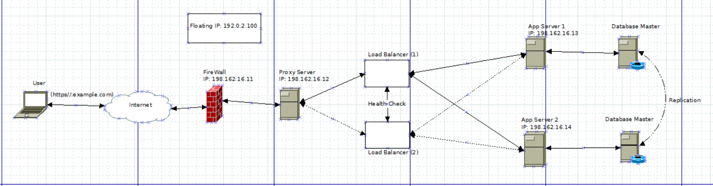

When the user make a request to the domain (https//:example.com) the request comes in and must pass through a firewall and a proxy server. The proxy server add another level of security and provides and helps manage traffic. It would then go to Load Balancer 1. Since there are two load balancers the concept of Floating IP addresses (helps so that DNS changes does not take to much time) is used and the two load balancers are constantly doing health checks on one another. Load balancer 1 is considered active as long as it is in good health and load balancer 2 is passive.Thus, if the first load balancer goes down then load balancer 2 become active and takes on the task of load balancing. I then have two servers in place to take on the requests, however this is scalable and can be increased depending on the size of a network and the network traffic that is coming through. The number of load balancers is also scalable and can be increased is necessary. I then have replicated the Database Master for the servers. Then the request is answered and goes back to the user.